Veterinary Science Math Question Bank
These are sample questions for test questions to be pulled from.
Note: Contest hosts are to change numbers and create new questions, with same format. Please do not copy exact questions plus numbers here. We want to prohibit straight memorization of questions.

- Your patient needs 1.5 g of a drug that is available as 750 mg/capsule. How many tablets will be dispensed if treatments are BID for ten days?
40

- A doctor orders 75 mg of Demerol IM every 4 hours for pain. It is available in 50 mg/ mL. How much should be injected over a 24-hour period?
9 mL

- A dog develops a hot spot and the veterinarian feels the best way to treat it is to use Prednisone (a steroid). Tablets contain 5 mg/tablet. The dog weighs 75 lbs and the recommended dosage is 5 mg /25 lbs. How many tablets will be given over five days if the medication is to be given OD?
15 tablets

- Green Apple shampoo can be bought in 5 gallon pails. If a groomer uses 16 oz bottles to hold shampoo, how many bottles can he get out of the 5 gallon pail?
40 bottles

- A German Shepherd weighs 46.7 kg. What is his weight in pounds?
102.7 lbs

- A sick cat weighs 3.5 kg. You must give it 20 mg/lb of a drug QID. What is the total dose?
616 mg

- A cow has a fever of 105 ºF. What is her temperature in Celsius?
40.5ºC

- Atropine is given at a dosage of 0.01 mg/lb of body weight. If the concentration is 0.5 mg/mL, how many mL should you give a 12 kg beagle?
.53 mg

- Nolvasan solution is prepared by adding 1 oz per gallon of water. If a mop pail holds 40 quarts of water and you want to fill it, how many tablespoons of Nolvasan should be used to get the proper dilution?
20

- When making 1200 mL of a 3% Lysol solution, how many grams of Lysol are used?
36 g

- You regularly order six 10-ml vials per month of a drug that has a concentration of 50 mg/ml. Now that same drug is only available in 20-ml vials of 10 mg/ml. How many vials should you order this month?
15 vials

- The veterinarian orders 4.4 mg/kg of Carprofen for pain control divided into two equal daily doses for a 50-lb dog. On hand are 100-mg scored tablets. How many tablets is/are administered each morning and afternoon?
.5 tablets in the morning and afternoon

- How many mgs of a drug should be given to a patient weighing 22 lb if the dose is 0.2 mg/kg?
2 mg

- Matt brings his newborn foal, Chayleigh in for dehydration. Chayleigh weighs 110 lb. The veterinarian instructs the technician to administer fluids at the rate of 70 ml/kg/24 hours. What is the total volume Chayleigh should receive in 24 hours?
3500 ml per 24 hours

- From the question above, calculate Chayleigh’s rate in drops/minute. Your clinic uses 10 drop/mL drip set for fluid administration. Round to the nearest whole drop.
24 drops/minute

- How many milliliters (mL) are in 6 ounces (oz) of liquid?
180 mL

- The veterinarian has asked you to calculate the pulse/heart rate for an animal in the clinic. You monitor the animal for 20 seconds and measure 23 beats in the 20 second time period. What is the pulse/heart rate for the animal?
69 bpm

- The doctor’s order reads: “Amoxicillin 225 mg p.o., q12 hrs.” The bottle from pharmacy is labeled: “250 mg = 5 ml.” How many milliliters would you give per dose?
4.5 ml

- Indicate the number of tablets prescribed for the following order:
Rx: Metronidazole tablets 50 mg
Sig: 2 tablets, P.O., BID x 10 days

40 tablets

Use the following statement to answer questions 20-23
Mrs. Kidd brings in her dog, Killer. Dr. Peelman has diagnosed Killer with a urinary tract infection. She has prescribed SMZ-TMP. Killer is Chow and weighs 70 lbs. The dose is 30 mg/kg once
every 12 hours. Killer will need to be treated for 10 days. Each tablet costs $0.75 and there is a one-time dispensing fee of $7.50

- What is Killer’s weight in kilograms?
31.8kg

- How many tablets per dose will be given to Killer?
2

- How many tablets will need to be sent home for Killer’s entire course of treatment?
40

- What is the total medication cost to Mrs. Kidd?
. $37.50

Use the following image to answer questions 24-25:

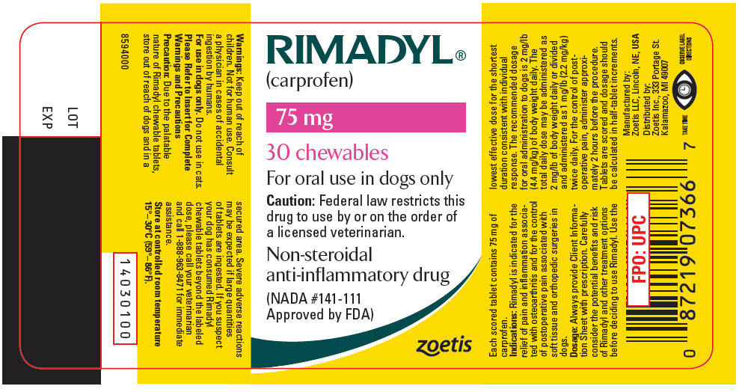

- How many total milligrams are in the bottle?
2250mg

25. The recommended dose in milligrams for a 12 kg dog is:
52.8mg

